**POWER BI**

**Overview:**

The primary purpose of this Power BI report is to empower dental professionals with a centralized and data-driven view of their practice's performance. By consolidating and visualizing key data points, the report aims to assist in optimizing various aspects of the dental app's operations, ultimately leading to enhanced efficiency, financial stability, and improved patient experiences.

**Data Source: API Integration**

The Power BI report is integrated with a live API as the primary data source. This API connection enables real-time access to essential information, allowing for up-to-date and dynamic visualizations within the dental app's Power BI reporting solution.

**Data Modelling:**

In the Data Modelling phase, the raw data extracted from the API has been structured and transformed into three distinct tables: the Master Table, Invoice Table, and Client Table. Additionally, the Invoice Amount Table and Payment Table were derived from the Master Table to further enhance data analysis capabilities. During this process, the necessary adjustments were made to ensure the appropriate data types for each column.

**Master Table:**

The Master Table serves as the primary dataset, connected directly to the API. It contains a comprehensive collection of information, including client details, invoice records, and payment transactions. This table forms the foundation for the subsequent data models.

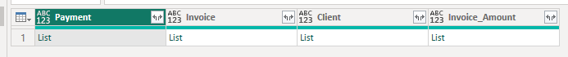

**Invoice Table:**

Extracted from the Master Table, the Invoice Table focuses specifically on invoice-related data, such as invoice numbers, due dates, and associated client information. The relevant columns were adjusted to their respective data types to ensure accurate representation and efficient analysis.

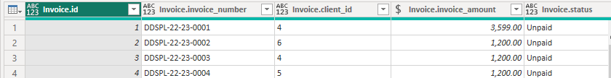

**Client Table:**

Derived from the Master Table, the Client Table concentrates on individual client details, such as names, contact information. The appropriate data types were applied to each column, enabling proper filtering and sorting within the Power BI report.

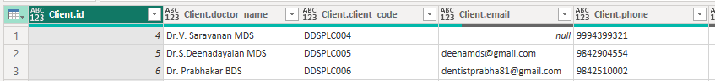

**Invoice Amount Table:**

This table was generated to provide a focused view of invoice amounts and their corresponding invoice numbers. It aggregates the invoice data from the Master Table and includes the necessary data type conversions for precise calculations.

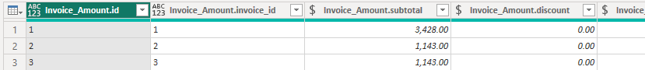

**Payment Table:**

Similar to the Invoice Amount Table, the Payment Table is derived from the Master Table and centers on payment-related data, including payment dates, amounts, and linked invoice numbers. The column data types were adjusted accordingly to facilitate accurate calculations.

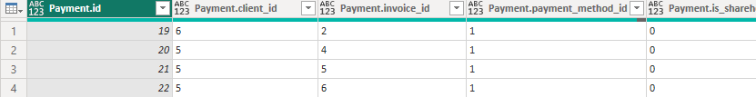

**Due Age Calculation:**

A new column named "Due Age" has been added to the dataset using the Date function during the data transformation process. The "Due Age" column provides valuable information regarding the age of outstanding payments or overdue invoices.The "Due Age" calculation is based on the due date of each payment or invoice, and it represents the number of days between the current date and the due date. This allows dental practitioners and administrators to easily track the duration for which payments have been pending and promptly address any overdue invoices.By incorporating the "Due Age" column into the data model, the Power BI report gains an essential metric for monitoring payment patterns and managing financial efficiency within the dental app. This timely insight enables users to identify outstanding payments, prioritize follow-ups, and optimize cash flow management for improved business operations.

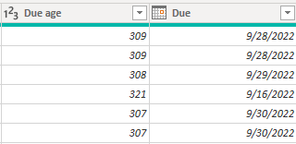

**Dashboard Page 1 : Financial Overview**

The first page of the Power BI dashboard focuses on providing a comprehensive financial overview of the dental app. This page consolidates essential financial metrics and trends, empowering users to gain valuable insights into the practice's revenue generation, payment patterns, and tax-related information.

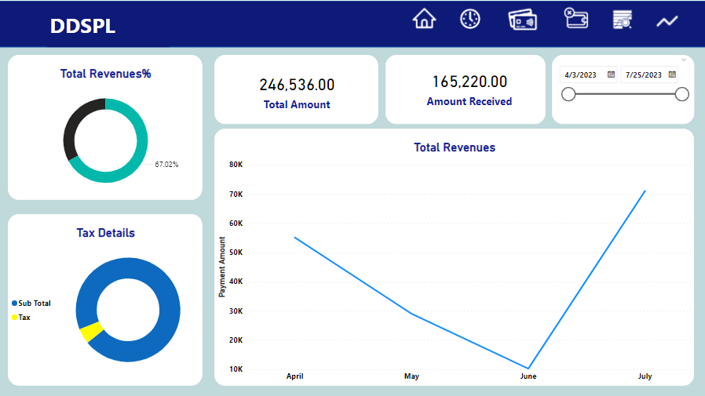

**Total Payments Received:**

This section displays the total amount of payments received from clients, representing the overall revenue generated by the dental practice.

**Total Invoice Amount:**

The Total Invoice Amount section presents the cumulative value of all generated invoices, highlighting the total billings for services provided.

**Monthly Amount Received (Line Chart):**

The Monthly Amount Received line chart illustrates the trend of payments received over time, organized on a monthly basis. This visual aids in identifying patterns and fluctuations in revenue.

**Tax Information (Pie Chart):**

The Tax Information pie chart provides a clear breakdown of tax-related data, including various tax types or rates applicable to financial transactions.

**Dashboard Page 2: Due Dates and Payments**

The second page of the Power BI report is dedicated to providing a comprehensive view of client due dates, payment history, and outstanding balances. This "Due Dates and Payments" page equips dental practitioners and administrators with essential information to manage overdue payments effectively and enhance the dental app's financial efficiency.

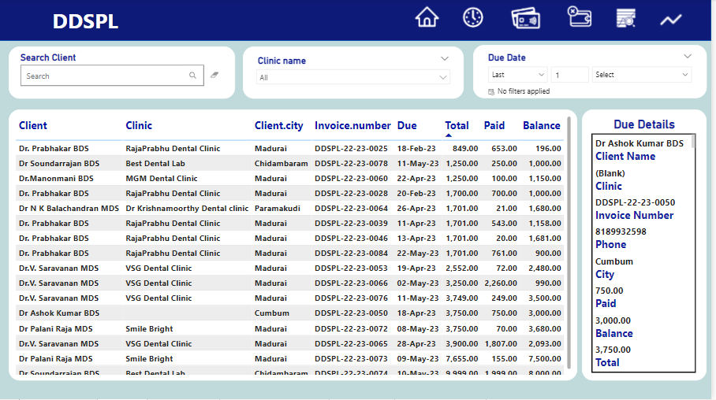

**Client Due Dates:**

This section lists all clients with their respective due dates. The due dates represent the scheduled payment dates for outstanding invoices.

**Partial Amount Paid:**

The Partial Amount Paid column displays the amount paid by each client against their outstanding invoices. This information helps in understanding the partial payments made by clients.

**Balance to Be Paid:**

The Balance to Be Paid column calculates the remaining amount that each client needs to pay for their outstanding invoices. This data enables prompt follow-ups and ensures complete payment recovery.

**Dashboard Page 3: Payment Details**

The third page of the Power BI report provides an in-depth analysis of payment details, including payment dates, amounts paid, and outstanding balances for each client. This "Payment Details" page equips dental practitioners and administrators with comprehensive information to efficiently track payment transactions and ensure timely financial management.

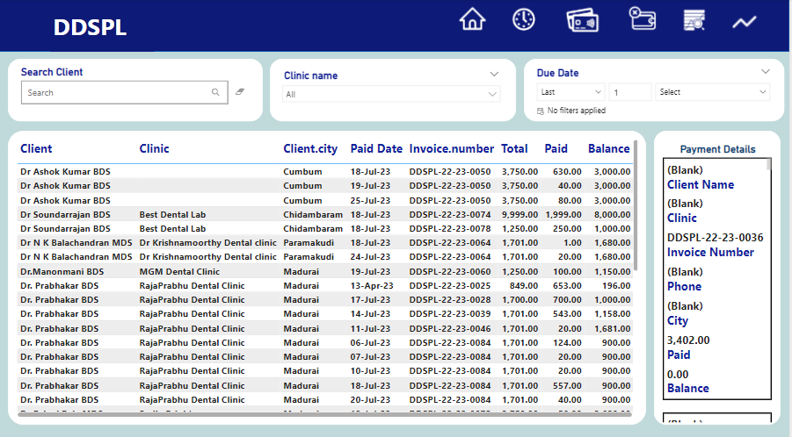

**Payment Dates:**

This section presents a chronological list of payment dates, showing when clients made their respective payments.

**Amount Paid:**

The Amount Paid column displays the specific payment amounts made by each client on their respective payment dates.

**Outstanding Balance:**

The Outstanding Balance column calculates and displays the remaining balance for each client after each payment. This information allows for easy tracking of pending payments.

**Dashboard Page 4: Pending Payments**

The fourth page of the Power BI report focuses on presenting a list of clients whose due dates have passed, yet the payment amounts remain unpaid. This "Pending Payments" page assists dental practitioners and administrators in effectively tracking overdue payments and taking appropriate actions to recover outstanding amounts.

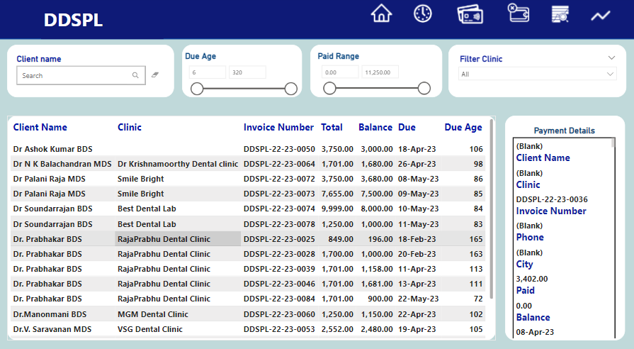

**Overdue Clients:**

This section lists all clients with overdue payments, organized by their respective due dates that have already passed.

**Outstanding Balance:**

The Outstanding Balance column displays the amount remaining to be paid for each client's overdue invoices.

**Filter by Partial Payment:**

This feature allows users to apply filters based on specific payment amounts. By setting a filter, the page displays only those clients who have paid a partial amount but still have outstanding balances.

**Dashboard Page 5: Client Analysis**

The fifth page of the Power BI report presents a comprehensive client analysis through insightful bar charts, showcasing essential financial metrics for each client. This "Client Analysis" page empowers dental practitioners and administrators with a holistic view of client transactions, total amount paid, outstanding balances, and overall financial engagement.

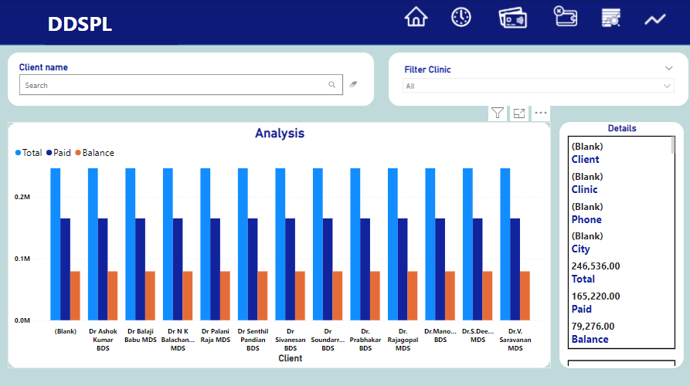

**Total Amount Paid (Bar Chart):**

The Total Amount Paid bar chart displays the total payments made by each client. Each bar represents a client, and the height of the bar represents the total amount paid by that client.

**Outstanding Balance (Bar Chart):**

The Outstanding Balance bar chart illustrates the remaining unpaid amount for each client. Each bar represents a client, and the height of the bar corresponds to the outstanding balance.

**Total Amount Owed (Bar Chart):**

The Total Amount Owed bar chart represents the total amount owed by each client, considering both the paid and outstanding balances. Each bar reflects the total financial engagement of a client with the dental app.

**Dashboard Page 6: Clinic and City Analysis**

The fifth page of the Power BI report is dedicated to providing a detailed analysis of clinic-wise and city-wise financial metrics through funnel and column bar charts. This "Clinic and City Analysis" page empowers dental practitioners and administrators with actionable insights into the distribution of invoices, clients, and total amount paid across different clinics and cities.

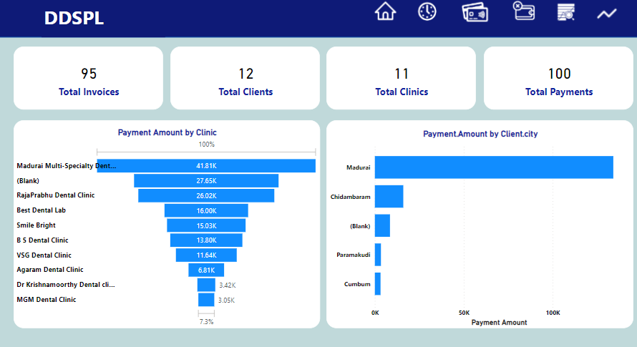

**Total Invoices by Clinic (Funnel Chart):**

The Funnel Chart visually represents the count of total invoices generated by each clinic. The width of each funnel stage corresponds to the number of invoices, allowing users to compare the invoice volumes across different clinics easily.

**Total Clients by Clinic (Funnel Chart):**

The Funnel Chart showcases the count of total clients associated with each clinic. The funnel stages' width corresponds to the number of clients, providing a clear view of client distribution across clinics.

**Total Amount Paid by Clinic (Funnel Chart):**

The Funnel Chart visualizes the total amount paid to each clinic. The funnel stages' width indicates the sum of payments received by each clinic, allowing for a quick comparison of the financial performance across clinics.

**Amount Paid by City (Column Bar Chart):**

The Column Bar Chart presents the total amount paid by clients from different cities. Each column represents a city, and its height corresponds to the total payment amount received from that city. This visualization aids in understanding payment trends across various geographical locations.

**Conclusion:**

In conclusion, the Power BI report for the Dental App provides valuable and actionable insights into financial performance, overdue payments, and client analysis. With organized data and intuitive visualizations, dental practitioners and administrators can make informed decisions, streamline operations, and enhance the overall financial management of the practice.

**\*\*\*\*\*\*\***